
Year 11 ATAR Chemistry
Practical Assessment – Validation Test
Chromatography

NAME: ________________________ TEACHER: ________________________ MARKS: _____ /20
Answer each question in the space provided.
- Describe the two following applications of chromatography. (2 marks)
- Normal-phase chromatography:

- Reverse-phase chromatography:

- What is the purpose of the stationary phase in chromatographic separations? (1 mark)

- What is the purpose of the mobile phase in chromatographic separations? (1 mark)

- Complete the following table: (6 marks)

Analytical technique: | Composition of mobile phase: | Composition of stationary phase:
Thin-layer chromatography
Gas chromatography
High performance liquid chromatography
- Label the following items in the diagram of a gas chromatography instrument. (4 marks)
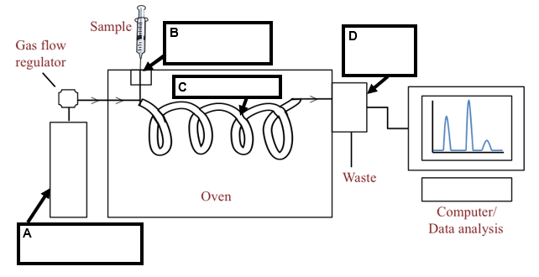

- What are two applications of high-performance liquid chromatography? (2 marks)
1.
2.

- What is a detector that is used for the following techniques? (2 marks)
  - Gas chromatography:

  - High-performance liquid chromatography:

- Explain how retention times in chromatographic techniques can be used to determine the composition of mixtures. (2 marks)

End of Validation Test

